Assignment 3: Applied Project Problem Analysis
GRAD 695-92-O-Fall
Matthew Sabo
- Introduction
  - Problem Statement
Executive functioning is the set of mental processes essential to the planning, organizing, and adapting of goals and daily tasks many would call mundane, like cooking dinner or arriving to work on time (ADDA, 2025). However, for people who have Attention Deficit Hyperactive Disorder (ADHD), these essential executive functions can be disrupted, which is referred to as executive dysfunction. Executive dysfunction can affect the brain’s ability to have issues with prioritizing and sequencing steps needed to complete a task, switching or starting a task, and meeting deadlines or obligations (ADDA, 2025). Those with ADHD tend to miss deadlines, not finish projects, and have unmet obligations that could prevent opportunities, strain relationships, and overall, negatively impact their mental health (ADDA, 2025). A way individuals with ADHD can mitigate their executive disfunction is splitting daily tasks and goals into “sub tasks” to make larger ones seem more achievable. These sub-tasks can be split further into “micro tasks” as needed. This project plans to address this issue by creating an application that would allow the user to input a task and then break down the task into more manageable sub-tasks which can help people suffering with executive dysfunction complete everyday tasks.

- Overall Description
  - Product Perspective
This application will enable people who struggle with executive dysfunction to more easily complete tasks and create habits without getting overwhelmed too quickly.

  - Product Functions
The proposed application will be able to:
- Act as a task list
- Automatically generate sub-tasks for tasks
- Help create habits
  - Operating Environment
The software will be developed using Java and will be able to be ran on any system that both supports Java and can connect to the internet. The Graphical User Interface (GUI) components will require a device with a screen to operate.

The database that will store the system information will be on a Linux-based server using MySQL. For the use of the program, the typical environment will either be a Microsoft Windows or Android device.

  - Design and Implementation Constraints
This software will be designed and implemented during the duration of an Applied Project. All design and development must be completed within the time frame allotted to this project.

  - User Documentation
User documentation detailing the configuration and execution of the software will be delivered with the finished software.

- System Requirements
The following are the various types of requirements for the proposed application:

  - Functional Requirements
The following are the functional requirements of the system:
- Create an Account and login to that account
- Input a task and receive a list of tasks in return
- Create habits that are repeated on a recurring basis
- Send notifications to device
- Store user information in a SQL database
- Breakdown subtasks into further subtasks up to 2 times
- Remember user details after closing application

  - Non-Functional Requirements
The following are the non-functional requirements of the system:
- The system should be a Java based application
- The application should be accessible on any device that can run a Java Runtime Environment (JRE) but primarily be developed for Android devices
- Follows all industry standard security protocols regarding user information
- Has UI that is easy to use and navigate
- Send notifications for habits at scheduled time
- Send notification if task is left uncomplete

  - Performance Requirements
The performance of the application is measured based on the user experience and the efficiency of the algorithm.
- Application functions must be available within 5 seconds of startup
- Tasks will break down within 10 seconds
- Any configuration changes made by either the user or system administrator should be made instantly
- Switching between menus must load within 3 seconds

- Use Cases
  - Use Case 1: Creating an Account
Description:
- A new user will create a new account through the application writing their name, email address, and password. This information gets sent to the back end of the application where it is connected to an SQL database so that the information can be saved. If the registration is successful, the application logs the user into the system. If the registration is unsuccessful due to an already existing account using the email, it returns an error message.

Use Case 1 Main Flow: UC1M
Step ID | Actor | Action | Notes & References
UC1M-1 | User | User clicks on the “Sign Up” or “Create Account” button.
UC1M-2 | System | The system presents a registration form to the user, requesting the following information:  - Name  - Email Address  - Password  - Confirm Password
UC1M-3 | User | The user enters the name, email address, password, and confirm password and clicks on the submit button.
UC1M-4 | System | The system checks if any of the fields are empty. It then checks if the email address is already used and in the correct format. | UC1A-A  Email Address is either not available or in the incorrect format  UC1A-C  One of the fields are empty
UC1M-5 | System | The system verifies that the password meets security requirements and matches the confirm password | UC1A-B  Password does not match conditions
UC1M-6 | System | System creates the user in database | UC1E-A  Problem with DB when creating new user
UC1M-7 | System | User is automatically logged into the application.

Use Case 1 Alternative Flow A: UC1A-A
Step ID | Actor | Action | Notes & References
UC1A-A-1 | System | If the email is not available or in the incorrect format, the system displays the following error message to the user: “Email is already registered or incorrect. Please retry or login.”
UC1A-A-2 |  | Return to UC1M-3

Use Case 1 Alternative Flow B: UC1A-B
Step ID | Actor | Action | Notes & References
UC1A-B-1 | System | If the password does not match either the security requirements the system displays the following message to the user: “Password too weak.”. If the password does not match the confirm password field the system displays the following message to the user: “Passwords do not match.”.
UC1A-B-2 |  | Return to UC1M-3

Use Case 1 Alternative Flow C: UC1A-C
Step ID | Actor | Action | Notes & References
UC1A-C-1 | System | If any of the fields are not filled in, the system displays the following message to the user: “Please complete required fields”
UC1A-C-2 |  | Return to UC1M-3

Use Case 1 Exception Flow A: UC1E-A
Step ID | Actor | Action | Notes & References
UC1E-A-1 | System | If the system encounters an unexpected issue while trying to create a user account in the database, the system will display the following message to the user: “System Error. Please try again later.”
UC1E-A-2 |  | End of Use Case

  - Use Case 2: Logging into the Application
Description:
- A returning user will input their email address and password into the application. This information gets sent to the backend of the application where it will check that the account exists. If the account exists then it will log the user in. If it doesn’t exist, then it will return an error message.
Use Case 2 Main Flow: UC2M
Step ID | Actor | Action | Notes & References
UC2M-1 | User | User clicks on the “Login” button
UC2M-2 | System | The system presents a login form to the user, requesting the following information:  - Email Address  - Password
UC2M-3 | User | The user enters the email address and password and then clicks on the login button.
UC2M-4 | System | The system checks if any of the fields are empty. Then the system checks if the email address is in a valid format. | UC2A-A  Email Address is not in a valid format  UC2A-C  Login fields are empty
UC2M-5 | System | The system connects to the database | UC2E-A  Problem with DB when connecting
UC2M-6 | System | The system checks if the email is linked to a valid account and the password is correct for that account | UC2A-B  Password is not correct or email is not linked to a account
UC2M-7 | System | User is logged into the application.

Use Case 2 Alternative Flow A: UC2A-A
Step ID | Actor | Action | Notes & References
UC2A-A-1 | System | If the email is not in a valid format, the system displays the following error message to the user: “Email or Password Incorrect. If you are a new user, please register for a new account.”
UC2A-A-2 |  | Return to UC2B-3

Use Case 2 Alternative Flow B: UC2A-B
Step ID | Actor | Action | Notes & References
UC2A-B-1 | System | If the email does not match any existing account or if the password does not match the given account, the system will display the following error message to the user: “Email or Password Incorrect. If you are a new user, please register for a new account.”
UC2A-B-2 |  | Return to UC2B-3

Use Case 2 Alternative Flow C: UC2A-C
Step ID | Actor | Action | Notes & References
UC2A-C-1 | System | If the any of the login fields are blank, the system will display the following message to the user: “Please fill out all fields”
UC2A-C-2 |  | Return to UC2B-3

Use Case 2 Exception Flow A: UC2E-A
Step ID | Actor | Action | Notes & References
UC2E-A-1 | System | If the system encounters an unexpected issue while trying to access the database, the system will display the following message to the user: “System Error. Please try again later.”
UC2E-A-2 |  | End of Use Case

  - Use Case 3: User Inputs a Task
Description:
- A user inputs a task. The application inputs the information into the API where it is then asked to break the task down into sub-tasks. Those subtasks are returned to the user and placed under the task in a drop-down menu style.
Use Case 3 Main Flow: UC3M
Step ID | Actor | Action | Notes & References
UC3M-1 | User | User clicks on the “+” button on the dashboard
UC3M-2 | System | The system presents a text box to type in a task with a submit and close button below. | UC3A-A  User closes the window
UC3M-3 | User | The user enters the task and clicks “submit”
UC3M-4 | System | The system creates a request to break down the task into subtasks
UC3M-5 | System | The system sends that request to OpenAI | UC3E-A  Problem connecting to OpenAI
UC3M-6 | System | The system takes the response from OpenAI and links the subtasks to the original task
UC3M-7 | System | Subtasks are shown to user by placing them under the original task. System shows user the following message: “Task Created!”

Use Case 3 Alternative Flow A: UC3A-A
Step ID | Actor | Action | Notes & References
UC3A-A-1 | System | The system closes the “Create New Task” window.
UC3A-A-2 |  | End of Use Case

Use Case 3 Exception Flow A: UC3E-A
Step ID | Actor | Action | Notes & References
UC3E-A-1 | System | If the system encounters an unexpected issue while trying to access OpenAI, the system will display the task in the GUI and give the following message to the user: “Cannot break down task. Please try again later.”
UC3E-A-2 |  | End of Use Case

  - Use Case 4: Breaking Down a Task into Further Subtasks
Description:
- A user clicks the expand button on a subtask. The system will take that input into the API where it is then asked to take that subtask and generate 7 further subtasks. The subtasks are then updated and returned to the user
Use Case 4 Main Flow: UC4M
Step ID | Actor | Action | Notes & References
UC4M-1 | User | User clicks the breakdown task button
UC4M-2 | System | The system creates a request to break down the task into sub-tasks
UC4M-3 | System | The system sends that request to OpenAI | UC4E-A  Problem connecting to OpenAI
UC4M-4 | System | The system takes the response from OpenAI and links the subtasks to the original task.
UC4M-5 | System | Subtasks are shown to user by placing them under the original task.

Use Case 4 Exception Flow A: UC4E-A
Step ID | Actor | Action | Notes & References
UC4E-A-1 | System | If the system encounters an unexpected issue while trying to access OpenAI, the system will display the task in the GUI and give the following message to the user: “Cannot break down task. Please try again later.”
UC4E-A-2 |  | End of Use Case

  - Use Case 5: Creating a Habit
Description:
- User creates a task that is recurring, referred to as a “Habit”, and sets a time to recur. This information is sent to the API where it then updates the SQL database with the information required. If no error occurred, it then sends the confirmation back to the user.
Use Case 5 Main Flow: UC5M
Step ID | Actor | Action | Notes & References
UC5M-1 | User | User navigates to “Habits” menu and clicks on the “+” button
UC5M-2 | System | The system presents a habit form to the user requiring the following information:  - Task  - Time to Repeat  - Frequency  - (Optional) Subtasks  This menu also includes a close and a submit button | UC5A-A  User closes the menu
UC5M-3 | User | The user inputs the required information and clicks submit
UC5M-4 | System | The system connects to the OpenAI API | UC5E-A  Problem connecting to OpenAI
UC5M-5 | System | System creates request to break down task into subtasks and sends it to OpenAI API. Waits until response. | UC5E-A  Problem sending or receiving from OpenAI
UC5M-6 | System | System lists subtasks under original habit.
UC5M-7 | System | System connects to the database and stores the information. | UC5E-B  Problem connecting to Database
UC5M-8 | System | System shows user a confirmation message stating that the habit completion was successful. The habit is shown in the GUI

Use Case 5 Alternative Flow A: UC5A-A
Step ID | Actor | Action | Notes & References
UC5A-A-1 | System | The system closes the “Create New Habit” window.
UC5A-A-2 |  | End of Use Case

Use Case 5 Exception Flow A: UC5E-A
Step ID | Actor | Action | Notes & References
UC5E-A-1 | System | If the system encounters an unexpected issue while trying to access OpenAI, the system will display the task in the GUI and give the following message to the user: “Cannot break down task. Please try again later.”
UC5E-A-2 |  | End of Use Case

Use Case 5 Exception Flow B: UC5E-B
Step ID | Actor | Action | Notes & References
UC5E-B-1 | System | If the system encounters an unexpected issue while trying to connect to the database, the system will show the following message to the user: “System Error. Please try again later.”
UC5E-B-2 |  | End of Use Case

  - Use Case 6: Deletion of a Task
Description:
- User deletes a task or subtask. The system will then transmit that request to the API where it will then connect to the SQL database where it will then attempt to delete the task from the table. If the deletion is successful, then the task/subtask disappears from the user interface. If deletion is unsuccessful, then an error message will be returned and sent to the user.
Use Case 6 Main Flow: UC6M
Step ID | Actor | Action | Notes & References
UC6M-1 | User | User clicks the delete task button
UC6M-2 | System | If the task is not a subtask and is incomplete the system will show a menu asking if the user is sure that they want to delete the task with an option to close the menu or continue deletion. If the task is a subtask or is complete, then this step is skipped and directly moves to UCM7-3 | UC6A-A  User closes the delete task menu
UC6M-2 | System | System deletes task and any subtasks from the database | UC6E-A  Problem connecting to the database
UC6M-3 | System | Task is removed from user GUI
UC6M-4 | System | System sends the following message to the user: “Task Deleted Successfully”

Use Case 6 Alternative Flow A: UC6E-A
Step ID | Actor | Action | Notes & References
UC6A-A-1 | System | The system closes the delete task menu and stops task deletion.
UC6E-A-2 |  | End of Use Case

Use Case 6 Exception Flow A: UC6E-A
Step ID | Actor | Action | Notes & References
UC6E-B-1 | System | If the system encounters an unexpected issue while trying to connect to the database, the system will show the following message to the user: “System Error. Please try again later.”
UC6E-B-2 |  | End of Use Case

- UML Diagrams
The following diagrams will be changed with further work on the project.
  - Use Case Diagram
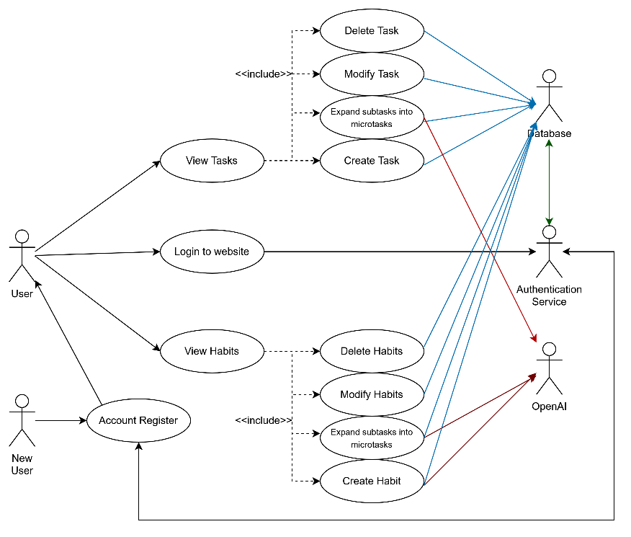
  - Class Diagram
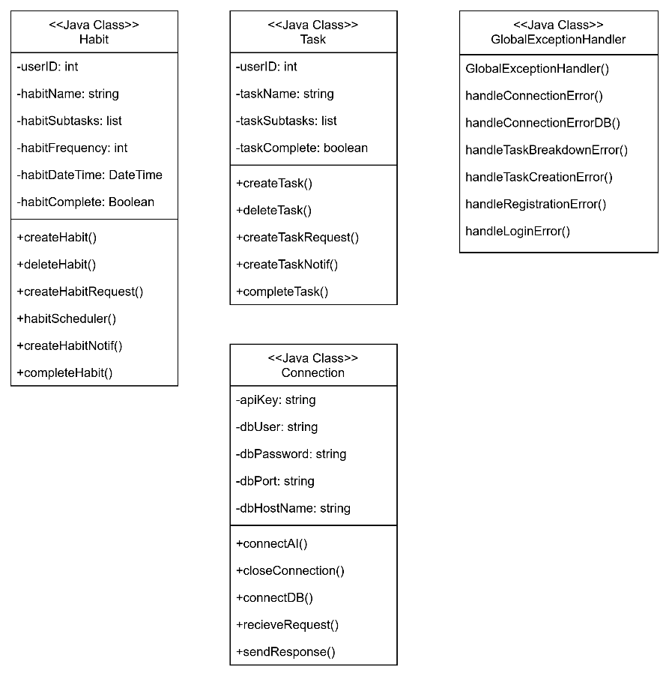

  - Sequence Diagram
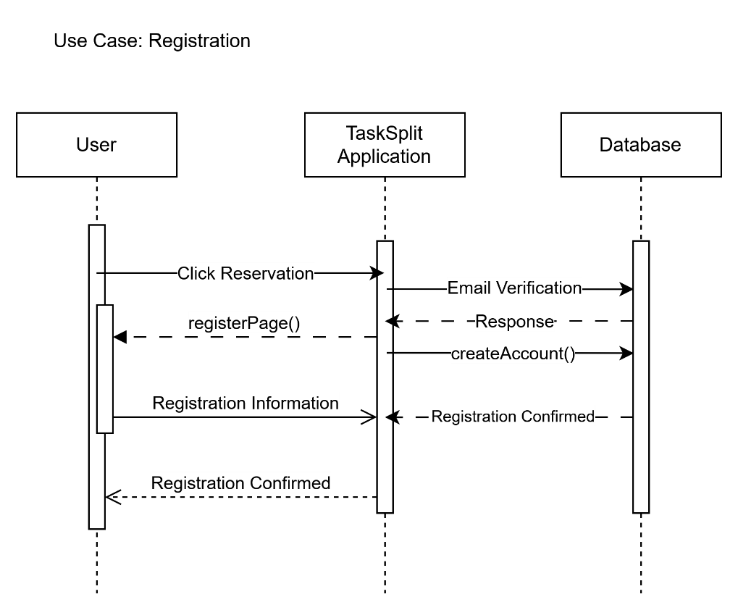

- References
ADDA Editorial Team. (2025). Executive Function Disorder & ADHD. ADDA - Attention Deficit Disorder Association. https://add.org/executive-function-disorder/

